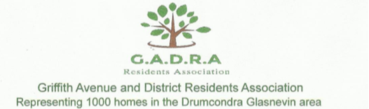

**Metrolink Submission Railway Order (RO) 2022**

**Introduction**

Griffith Avenue and District Residents Association (GADRA) represent over 1000 homes along the route of MetroLink. We welcome the Metrolink project and have engaged with TII since the start of the project in order to improve the project, minimise the negative impacts on our community and, in particular, to protect the mature trees within our area.

**Fee Requirement for Participation**

GADRA objects to the required fee payment to ABP to make a submission on this SID especially for residents who are living beside Station, Shaft, Compounds ,orTunnels or who are living along construction traffic routes. This is unfair and places undue hardship on those who wish to participate in this process, which is their right under Aarhus. No one should be denied this right because of financial difficulties. This needs to be rectified by ABP and fees paid by those within the zone of influence should be refunded. In addition, ABP need to make it a condition that going forward this fee is waived for those living beside these massive construction sites, those on social welfare or anyone in hardship.

**Access to Independent Expert Advice**

A precedent was set during the MetroNorth project of access to Independent Expert Advice for all residents along the Route of MetroNorth. This advice was available to residents for this project through the services of RINA, who were of great help to the many resident groups along the route. We have several observations in relation to the provision of such a service, including:

* We believe that the Independent Expert Advice should be available earlier in the project. Access to such advice was requested by GADRA from the first open day on the project. In MetroNorth, Drumcondra residents had access to the independent expert advice early in the project in relation to the alignment-The Madden report. In fact, GADRA were involved in setting up the Terms of Reference for the Madden report, which was carried out independently and resulted in a realignment in the Drumcondra area that the RPA stated was an improved alignment and one that they supported at RO. Many of the issues that we and other resident associations have on Metrolink, could, and should, have been sorted out well before railway order stage. Indeed, the approach of the NTA appears to have been in this project to put in a Railway Order application and see what they can get away with from An Bord Pleanala, rather than engage with those affected by the proposals to address their concerns!
* We do not believe the agency (NTA/TII) tasked with the delivery of the project should be involved in the setting of the terms of reference for the Independent Expert Brief. We addressed this with Minister of Transport who simply deferred to NTA. Independent expert advice improves a project for both the applicant, for the city and for the residents - if the experts and therefore the residents are given the information in a timely fashion at an early stage of the project. This did not happen in this case. Indeed, RINA's final report to residents had to be approved by TII prior to circulating it to the resident stakeholders - this is not acceptable. Indeed, approval by the TII serves to undermines its independence.
* We note that in this project, unlike MetroNorth, the Experts appeared to have difficulty obtaining information from TII and, indeed, were not even informed of the timing of the application for Railway Order. They did not see any of the EIAR, which contained answers to many of the questions residents raised, ahead of the RO, which meant the independent expert report was not available until 6 weeks into the consultation period, giving residents just two weeks to make submissions. In the RINA (Independent Experts) Interim Report, it states that for 70% of resident’s questions to the TII, an answer was provided that was not comprehensive, not did it provide as much information as was expected. See below from the RINA Stakeholder Consultation before RO September 2022

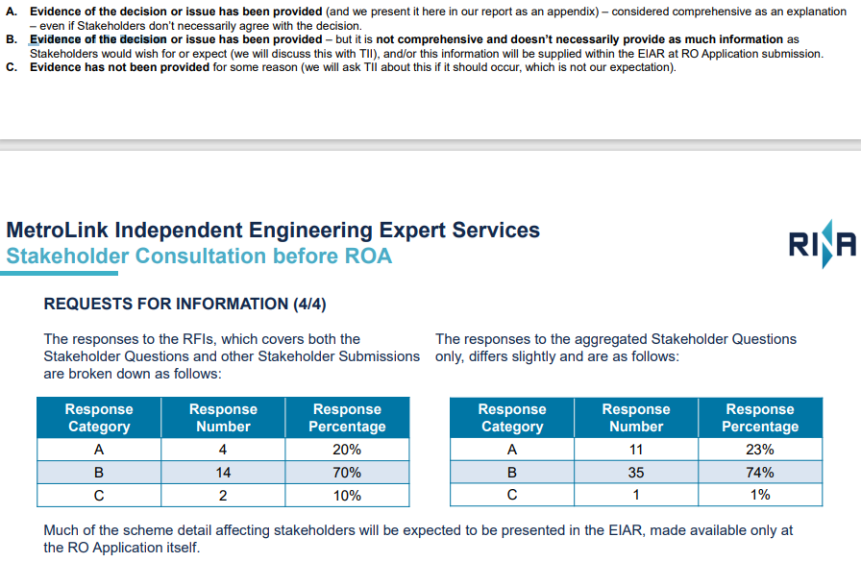



* GADRA believe it is **critical** that independent expert advice is available to residents and stakeholders during the enabling works and the construction phase, and we are requesting that ABP make this a condition of the RO. This approach is common practice throughout the world on Metro projects, with the experts being employed by the entity who is paying for the project- i.e., the Government and, by association, the taxpayers of the Country. Both the Government and residents should have access to real time information on construction deadlines, including any associated delays or changes in design, in addition to all relevant environmental information etc., which should be shared and explained in real time. Tunnelling is a dynamic process and changes are required to be made in real time - literally at the interface of the TBM and rock/earth as the conditions encountered change. Residents need to be confident that such decisions, which can result in deviations and changes that could impact on residents and stakeholders are the optimal decision, made against a robust and transparent set of criteria, with appropriate governance and oversight, in addition to being made for construction reasons rather than any attempt to cut corners. Settlement, which is a huge fear among all residents, is dependent on many considerations, one of which is the speed with which grouting occurs after the TBM – this needs oversight by Independent Experts. As residents cannot monitor this themselves in the tunnels, access to such Independent Experts is vitally important for providing assurance to residents. For the Taxpayer it is of upmost importance that any delays are highlighted immediately so that real time intervention can occur – we simply cannot have a rerun of the Children’s Hospital Build – with financial over run and long delays. The Experts can identify and inform government immediately, which in turn will have the potential for huge savings in the long run.

GADRA are asking that ABP makes the appointment of Independent Experts for the enabling works and construction phase a condition of granting the railway order. We further request that this aspect of the project is under the ownership of Dept of Finance, Enterprise or Transport but definitely not the NTA.

GADRA are supporting the call for  a Residents Monitoring Group so that Environmental impacts such as noise, vibration, traffic, dust, working hours, timelines etc. and the effectiveness of any construction mitigation measures - Agree monitoring and reporting templates – Reports are available for all residents to review in real time with a role for Independent Experts here also to provide oversight as to completeness of information bring shared

We support the calls of Prospect ACA in calling for a Community Fund to be set up, again similar to the children’s hospital fund.

**Stakeholder Engagement**

GADRA believe that so many of the issues that we have today could have been addressed prior to Railway Order. However, despite the early and enthusiastic engagement on our side, we found that TII did not respond to us. In fact, we never had a meeting with the TII, despite requesting this and attending NTA offices to meet with project manager to be told by Mr Hugh Creegan that TII would not be attending the meeting (March 12th Meeting in NTA offices). We have engaged with TII since the very start of this project sending our first questions to the TII in 2018 once we notice the drones above our homes.

**Risk to Dublin City should project start and then stop for unforeseen circumstances**

GADRA raised this issue with the Independent Experts at our first meeting November 11th, 2021, and RINA raised it with TII who confirmed that, at that point, it had not been included it in their Risk Register. Our concern is that should construction start on the top-down excavations of the Shaft and station boxes and then the project stalls or is held up through unforeseen circumstances e.g., a lack of required building materials, global instability, war, pandemic, lack of workers, financial issues etc., we, the public, could be left with dangerously deep, unsightly holes in the ground throughout the city. We believe that mitigations should be identified to ensure the likelihood of such a scenario arising is minimised, but also that plans are established to ensure that the impact is minimised in the event it does occur - which could impact on the construction approach adopted. GADRA requested through the experts that this issue and the mitigations be considered in the plan and detailed in the related Project Risk Register. However, as that is not part of the EIAR, we do not know if this has been addressed. We are requesting that ABP make this a condition before granting the RO. This is an issue for all residents, but GADRA are especially concerned for residents in the Charlemont area and in the vicinity of Glasnevin Station, as the final completion of their area is dependent on further development of Metrolink and other transport projects which may not occur.

**Specific Issues being Raised**

Our issues in relation to the Metrolink are as follows:

* The decision to go from Twin Bore to Single Bore and the lack of supporting documentation
* Intervention Shaft Issues, including:
  + The lack of consultation on the shaft position.
  + The lack of any evidence of an alternative to the shaft.
  + The lack of evidence supporting the size of the shaft in the EIAR.
  + The size of the footprint of the shaft in both construction and operation phase.
  + The withholding of information on the shaft during the consultation on the EPR.
  + The lack of information in relation to Intervention Shaft within the EIAR especially in relation to construction traffic, base line sound measurements - it appears to not have been included (most like as it appears to have been a late addition to the project).
  + GADRA's proposal for Dublin Fire Brigade Access ACP Shaft to be outside of the park on Ballymun road rather than be in the park as part of the shaft footprint.
  + The fact that there are alternatives to the carpark/ emergency vehicle area outside of the park that also comply with industry safety standards has not been shown in the EIAR.
* The position and rationale for position of Collins Avenue station
* The move to the current position for the Griffith Park Station
* The proximity of the Griffith Park Station to the highly sensitive Tolka river

**The decision to go from Twin Bore to Single Bore and the lack of supporting documentation**

As previously mentioned, following the announcement in March 2018 of the EPR, a large campaign was mounted by Na Fianna and the local schools to remove the Launch site and Station from Na Fianna - Section 7.7.2.1. This campaign had much support from locals and politicians. When the TII announced the Preferred Route (PR) in April 2019, decisions had been made to:

a) move the TBM launch site

b) move the station from Na Fianna to Homefarm football pitches

c) change from Twin Bore to Single Bore

The movement of the launch site from the Na Fianna did not in itself necessitate the change from Twin to Single bore and we note that the EIAR does not give the rationale for that decision. We ask that ABP ascertain the rationale for this decision, the supporting documentation, the options considered and ensure the validity and robustness of the decision. GADRA contend that as the information on the basis on which NTA/TII made the decision to change from Twin Bore to Single Bore is not included in the EIAR, the EIAR is incomplete and therefore it is not possible to make a complete submission until this information is provided. NTA/TII appear to us to have made the decision to change from a Twin Bore to a Single Bore tunnel following the very comprehensive campaign to move the launch site from Na Fianna. The campaign included support from the floor of the Dáil by the Taoiseach and Minister of Transport, in addition to thousands of submissions from all over Ireland (every Gaelscoil Child in Ireland sent submission in support of Scoil Mobhi, who opposed the station and TBM launch site in Na Fianna). GADRA fully supports the right of all the members of the public to engage in the decision making and lobbying, we also agree with the moving of the TBM launch site. However, the timing of the decision on Twin/Single bore and station location with the outcome of that campaign would suggest that the decisions are interlinked. However, we reiterate that moving the TBM launch site does not in itself necessitate the change in position of the station from Na Fianna, nor the change from Twin Bore to Single Bore, and we cannot see anywhere the rationale for these additional changes set out in the EIAR.

The only indicator within the EIAR for this change, beside pressure from Na Fianna and any potential cost reduction (which we believe is not to be a consideration for ABP), is a slight reduction in spoil from a Twin Bore to a Single Bore (ref Section 7.7.22). By contrast, there are a range of downsides to a Single Bore which are not detailed and potentially not considered in the decision making. Indeed, we note that Twin Bore Metros are the most common form for Metros throughout the world and are deemed to be safer from a fire safety point of view.

Overall GADRA feel the rationale for this decision, which has impacts for the whole Metro, and especially for our area, has not been provided and we are again requesting that ABP seek and consider this information prior to granting the Railway Order.

**Intervention Shaft and Collins Ave Station position**

GADRA would, at the outset, like to state that we object to the positioning of an Intervention Shaft in a public park, which will permanently remove an area of public park from public use.

The Intervention Shaft has a large above ground permanent footprint- Section 4.17.5 states *that Albert College Park is a large area of Non-residential land to construct the intervention shaft and house the permanent facilities*. Albert College Park is a public park that is highly valued and irreplaceable in the area. It is zoned as Z9 and should never be used as a car park or maintenance facility. Following discussion with our Independent Experts and much extensive research we are unable to find any other Metro system that has positioned a shaft and carpark/ emergency vehicle parking into a public park, which was confirmed by the Independent Expert.

The disruption to nocturnal wildlife at this site will be significant and GADRA are requesting no works on this site at night.

The moving of the station from Na Fianna to Homefarm pitch has caused the need for an intervention shaft and, despite GADRA asking as early as 2018 about any requirement for a shaft within our area, and constantly requesting information on this shaft, TII did not produce any information in relation to the shaft except for one sentence in the Preferred Route consultation. This shaft is a material permanent above ground structure, yet the public were not given any information on this shaft during the consultation phase and were not given any alternative site rather than in a public park. Indeed, the only consultation that occurred on the shaft was in relation to design, not position.

At a very early stage the Ballymun Road and Albert College Park residents (ACRA) identified a viable alternative, which would negate the need for a shaft in a park. GADRA have included the ACRA Ballymun Road Residents Associations proposal to move the Collins Avenue Station to the Albert College Park in the position it was previously approved by ABP in the MetroNorth application, or more south in the park, thus removing the need for a shaft in the park. There would be a need for a shaft between Collins Avenue and Ballymun, but this could be located in an area of Ballymun Library Car Park, well away from homes and not in a public park. Given the level of public transport with Metro and CBC, we would suggest that carparks along this route should be redundant in the longer term, and the current zoning on the carpark does facilitate a shaft, so it is a more appropriate location for it.

GADRA support the ACRA proposal and further question the decision to place a shaft in the park without the option of a station being considered as part of the consultation process.

GADRA would also request that the Inspector look at the Z9 zoning, which the area planned for shaft is currently zoned as. While such zoning does allow for green transport, GADRA do not believe that a ventilation shaft meets these criteria. A station within the park on Z9 lands however does fulfil the zoning requirements. Since the emergence of the Intervention Shaft proposal, GADRA have been asking that the alternate option of station at this location be considered, which would have a smaller footprint in the park in the longer term and would allow the public access the benefits of the station, which is after all positioned in a public park. An underground station, while disruptive during the construction phase, would in our opinion, have less significant impact once operational and have benefits for the public and would fulfil the zoning requirements. This station in the park should be constructed as a dual entrance station with a northerly entrance 70 meters south of DCU gates and a southerly entrance 100 meters north of Hampstead Avenue

Please see below the alternative proposal from ACRA:

This proposal would negate the need for a shaft in the public park.

This satisfied the current requirements

Please note below the argument our colleagues in ACRA and Ballymun Residents Associations have made to the TII and we fully support this-

*It is very clear that a very significant weighting is being placed on the comparison between the estimated passenger footfall at the Collins Avenue Station Location and the Albert College Park Station locations, in justifying TII’s stated preference to locate the station at Collins Avenue.*

*Given the importance of these metrics in justifying the station location, we are concerned that the modelling employed was generated much earlier in the EPR stage by ARUP - using a strategic modelling approach to look at different alignments, which is now outdated.*

*We are of the opinion that the strategic modelling employed does not accurately reflect the future passenger demands in the area. It shows an expected reduction in footfall from 17,250 passengers to 12,250 in a 24hr period if the station is moved 750 metres south of the proposed church location.*

*We do not believe that the strategic aggregated modelling employed accurately reflects both the current and future demands which will occur due to planned further development of the DCU Campus, as well as the future planned major apartment blocks to be built on the Eustace lands adjoining the park. This model would appear to be already outdated and grossly underestimates the future footfall to be expected due to these future developments.*

*Furthermore, TII also state that one of the reasons the park option was not considered was the impact which a station construction would have on the environs of the park, yet it must also be noted that the impact on the environs which will result from the construction of the proposed ventilation shaft on the park will also be very significant. “Furthermore, environmental impacts of constructing the station within the environs of the park and the proximity of the DCU Collins Avenue station to orbital bus routes operating along Collins Avenue were also differentiating factors between the two MSZs.”*

*Nor does it compare the current selected church station location to either the location option (option 3 Metro North) or our proposed Park station location.*

*“While both station zones were not directly assessed against each other”*

*We wish for our proposed Park station option at 12+640 – 12+760 to be modelled against the current Collins Avenue Church location at 12+164 – 12+278 and an appropriate level of detail provided comparing the two. This we believe will show that the decision to locate the station at the church based purely on footfall may not be in the best interests of the Metrolink project or indeed for the wider area.*

*Our proposed Park Station would be approx. 550 metres south of Collins Ave at 12+640 and it would be only 100 metres south (1 minute walk) from the DCU main gate entrance and a 7minute walk north to Collins Ave.*

*TII’s current proposed Church location at 12+164 is 125 metres south of Collins Ave (2 minute walk) and 360 metres north of the DCU main gate.*

*The location of park option (Option 3 from Metro North) used in the modelling is 750m south of Collins Ave approx. 9 minute walk north to Collins Ave.*

*Whilst our proposed Park Station Figure 2 below would be a further 400 metres (5minute walk) south of the current Church station location we would question the premise that an extra 5 minute walk would reduce footfall to such a degree given the vast majority of users of the station would be from DCU and the future housing developments located nearby.*

*Figure 2. Our proposed Park Station location.*

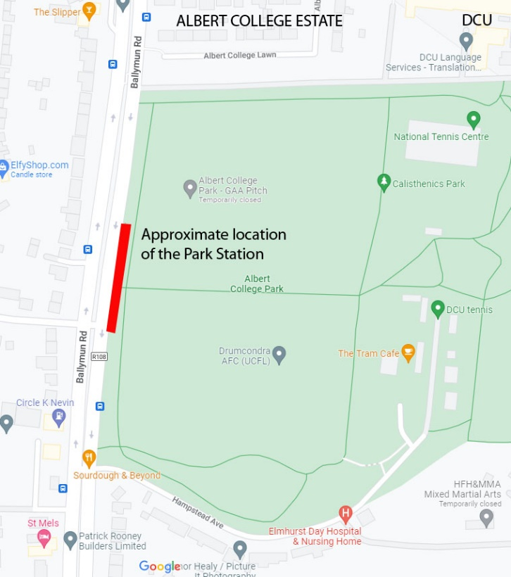

*RINA have validated our position, as did GWP Consultants who were the previous Independent Expert appointed during the Metro North Project, that a station location based in Albert College Park, coupled with a ventilation shaft north of Collins Avenue at Ballymun Library is a far better option, given that the major footfall for this station will be to and from DCU and the proposed residential developments at the Eustace lands. This location will also greatly reduce the expected severe traffic impacts and the negative impacts on the church goers, the OLV school children and parents, local residents in close proximity to the Church including the elder residents of Albert College Court & Albert College Estate.*

*We would therefore respectfully request that a revision of the previous modelling be carried out to reflect not just current, but also future footfall demands, which will provide a more balanced set of metrics on which to base such an important decision affecting the lives of so many stakeholders in the area.*

GADRA feel to not address this issue has been remiss of the NTA, and fully support the call for this to be carried out before granting the RO. We can also see nowhere in the EIAR where alternatives to avoiding the Shaft by positioning a station in the park are given. GADRA requested "The Collins Avenue Station: EIAR of the options" report in June 2022 but did not receive it until after the NTA made the application for RO.

**From**: "Griffith Avenue & District Residents Association" <[info@gadra.ie](mailto:info@gadra.ie)>  
**Sent**: Thursday, June 16, 2022 9:35 AM  
**To**: "Foley Aidan" <[aidan.foley@tii.ie](mailto:aidan.foley@tii.ie)>  
**Subject**: fw: Metrolink

Dear Aidan

Please could you forward to us a copy of the following document "**Collins Avenue Station: Environmental Assessment Report of the Options**" by Jacobs IDOM from 6/2/2020

Kind regards

Ruth

GADRA

Indeed the TII only released the Multi Criteria Analysis Appendix A on **17/11/2022 at 17:04** – this contains new information to all of the public including the Independent Expert. This new information on which the TII seemed to have made the decision for the position of Collins Avenue station is not part of the formal application. See below email trail:

**From**: "Suzanne Angley" <Suzanne.Angley@tii.ie>  
**Sent**: Thursday, November 17, 2022 5:04 PM  
**To**: "info@gadra.ie" <info@gadra.ie>  
**Cc**: "Metrolink Information" <info@metrolink.ie>  
**Subject**: FW: MetroLink - Collins Avenue Station: Environmental AssessmentReport of the Options

Hi Ruth,

I hope you are keeping well.

I just wanted to let you know that an updated version of the Collins Avenue Station: Environmental Assessment Report of the Options was published today on our website [Other documents shared with the public after date of application - MetroLinkWeb](https://www.metrolink.ie/en/news/latest-news/other-documents-shared-with-the-public-after-date-of-application/).

The updated document now includes the full Multicriteria Analysis Table in Appendix A.

Kind regards,

Suzanne

________________________________________________________________________________

**From:** Metrolink Information <[info@metrolink.ie](mailto:info@metrolink.ie)>  
**Sent:** Wednesday 26 October 2022 17:09  
**To:** [info@gadra.ie](mailto:info@gadra.ie)  
**Cc:** Metrolink Information <[info@metrolink.ie](mailto:info@metrolink.ie)>; Suzanne Angley <[Suzanne.Angley@tii.ie](mailto:Suzanne.Angley@tii.ie)>  
**Subject:** MetroLink - Collins Avenue Station: Environmental Assessment Report of the Options

Dear Ruth,

I hope you are keeping well.

Please find attached letter and copy of the Collins Avenue Station: Environmental Assessment Report of the Options.

The document is also available on the MetroLink website on the following page [Other documents shared with the public after date of application - MetroLinkWeb](https://www.metrolink.ie/en/news/latest-news/other-documents-shared-with-the-public-after-date-of-application/)

Please note the below information should you wish to reference this Report in your submission to An Bord Pleanála.

In this section, TII hosts documents shared with any member of the public after the date of the RO application, to facilitate access and promote transparency. These documents are working documents and other materials that do not form and are not required to form part of the application documents. As such, if you wish to refer to them in your submissions and observations to An Bord Pleanála you should include a copy of or link to same in your submission or observation, otherwise An Bord Pleanála may not have access to the original document.

Direct link to report [**Collins Avenue Station: Environmental Assessment Report of the Options**](https://www.metrolink.ie/media/dpnhlpvp/ml1-jai-egn-ms09_xx-rp-z-00001_for-information-only.pdf)

If I can be of further assistance please get in touch.

Kind regards,

Linda Carroll

MetroLink Stakeholder Communications Coordinator

Collins Avenue to Estuary

________________________________________________________________________________

**From:** Griffith Avenue & District Residents Association <[info@gadra.ie](mailto:info@gadra.ie)>  
**Sent:** Thursday 22 September 2022 13:39  
**To:** Suzanne Angley <[Suzanne.Angley@tii.ie](mailto:Suzanne.Angley@tii.ie)>; INFO <[Information@tii.ie](mailto:Information@tii.ie)>  
**Subject:** fw: RE: Metrolink

Hi Suzanne

We would be grateful for the following "**Collins Avenue Station: Environmental Assessment Report of the Options**" by Jacobs IDOM from 6/2/2020 and EIAR (Draft is fine)

Regards

Ruth

GADRA

It appears to us to only release this information with less than a week to go to closing date is extremely unfair. However, within this late information we note that, despite the change of scoring in option 3 Construction- setting this to a category 1 and not as was previously 3 (with no explanation for this change in text)- it still appears to us that there is still really nothing separating these two options in these environmental categories, and no apparent reason for choosing the current position. See website link below, as this was not submitted as part of application:

[Other documents shared with the public after date of application - MetroLinkWeb](https://www.metrolink.ie/en/news/latest-news/other-documents-shared-with-the-public-after-date-of-application/)

It would appear to us that one should really declare a weighting system BEFORE you undertake analysis and not afterwards. It makes us wonder are TII just trying to justify a decision that they had already made - especially since they have changed the scoring of one category without explanation. And even with all this, Option 1 is, at best, of equal weighting to Option 3 - and arguably less good on Environmental Categorisations. Of course, the MCA should have covered all of the categories – traffic walk in catchment land, use fit estimated demand, etc. - so poor and all as this analysis is, it is still incomplete having been withheld from the public until this late in the application period. GADRA request that this is fully addressed and that ABP refuses the request for the Collins Avenue Station in its current position. While not wanting to delay the Metro, the NTA/TII have been asked for this information on many occasions, and refused to engage prior to this application, which is in our opinion very obviously deficient.

We also note the manner in which Our Lady of Victories School has been treated in this process and would highlight how differently this school has been treated in comparison to the treatment and special allowances made for the Scoil Caitriona and the children in School Mobhi by moving the Griffith Park Station, and we ask why these children and school should not be afforded the same respect and consideration given the similarities in the impacts.

See below possible location of station in the park negating need for a shaft

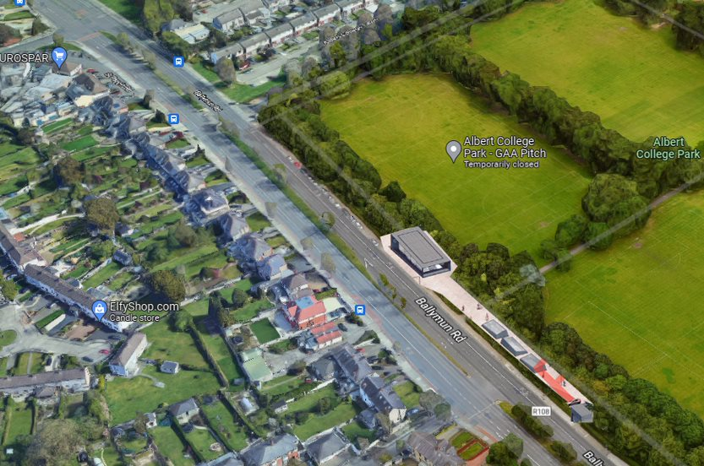

**Shaft Consultation**

Other than ‘one line’ in the TII documentation, no further details as to size and the above ground nature of the shaft was mentioned. It is our opinion that, as no information was available to the public during the consultation period on the Preferred Route, that the NTA/TII have not fulfilled the requirements of DPER's “Consultation Principles & Guidance” or their statutory obligations under the Aarhus Convention in terms of the underpinning pillars of access to information and public participation in decision-making in this regard.

One of GADRA's first questions to TII back in 2018 was whether there was going to be a shaft within our area. Following our experience in MetroNorth, we were aware of the potential for intervention shafts, in addition to the fact that intervention shafts are a completely negative structure along a Metro, giving no positive benefits to a community and resulting in only negative impacts, so often tends to be hidden (not put on maps) until consultation periods are over. An example still exists where the shaft is being omitted – Vol 4 Figure 1.1 and Chapter 7 section 7.2 (shaft is omitted).

Since March 2018 GADRA had been asking the NTA for information regarding any Intervention Shaft. Again prior to the official announcement of the Emerging Preferred Route (EPR), GADRA specifically asked NTA/TII if there was to be an Intervention Shaft in our area. At the first Open Day GADRA raised a question as to whether there was to be an Intervention Shaft between Griffith Park Station and Collins Avenue station and were told no. GADRA highlighted to the Project Director Metrolink, Mr Aidan Foley, at the Crown Plaza Day, the issues in relation to the Shaft in Metro North - we were again assured that that there was no shaft in our area.

When the Preferred Route (PR) was announced in March 2019, there were only 17 words included in relation to the Intervention Shaft in the documentation, with no detail as to whether the shaft was to be above or below ground. GADRA asked for this information immediately on the day of the announcement. GADRA attended the open day in the Gresham Hotel on April 10th, 2019 and asked again if the shaft was to be above ground. At that time, we also raised the suggestion that this shaft should become a station, but were told by the Project Director Metrolink, Mr Aidan Foley, that this would be too disruptive for the park.

At that time GADRA queried the reasons why the footprint around the shaft was larger than the footprints of all the other station boxes and were informed by the Project Director MetroLink that the sizes were indicative only, but that there would need to be sufficient room around the shaft to allow fire engines to turn. There is no need for Fire Engines to turn on this footprint as indicated in the EIAR Section 4.17.5, and as confirmed to GADRA by Dublin Fire Brigade (DFB) and confirmed in the EIAR, DFB have requested a one-way system with two exits – thus negating the need to turn vehicles. Indeed the ‘hand drawn map’ and footprint of the shaft has not changed since the drawing below was produced in May 2021.

The DFB have confirmed to us that they have had no input into the design of this shaft – this was confirmed to RINA by TII in RfI 21, as follows -

*Request for Information #21: A Stakeholder group member communicated to us having received the following information about the MetroLink Intervention shaft in the Albert College Park area, subsequent to their discussions with the DFB concerning their requirements for the design footprint of the Intervention Shaft. “The Dublin Fire Brigade have not had any input into the design for this shaft, but the design of shaft and foot print is all TII. DFB require in new builds just the legal requirements. DFB are having meetings along with many others in DCC currently but did not at the pre-design stage (the footprint was announced Dec 2019) “ Consequently, the local stakeholder group is interested to receive and analyse: • the legal requirements under planning for size of foot print required for an emergency shaft; • the reasoning for the large footprint as DFB did not request this during the pre-design phase. Therefore, as IEE we request the relevant information demonstrating the evidences and the reasoning behind the footprint requirements for the ACP IS, and particularly the requirements of the Dublin Fire Brigade.*

*TII Response #21 As DFB have noted, the design for the shaft and external footprint is wholly the responsibility of TII and our designers, Jacobs/IDOM and an indicative footprint was developed in 2019 based on best practise that fire tenders and other emergency response vehicles will require direct access to the shaft entrance and a suitably sized hard standing area adjacent to the emergency stairs and lift access point was included in this early design. As noted in our response to RFI 19, the current shaft design reflects the consultations held with DFB including a requirement is that externally, the Intervention Shaft must facilitate hard standing access for fire service appliances within 20m of the entrance to the shaft. In addition, the provision of a second vehicle entrance/exit from the intervention shaft from R108 was developed due to concerns expressed by DFB on ability of fire tenders and other large appliances to turn within the hardstanding area.*

DFB have only recently employed the experts Atkins to advise in relation to fire safety and since there has been no real changes to the shaft in size or overall footprint throughout this process, we can only conclude that TII decided that, because this shaft is being positioned in a park, they could take as much land as they wanted and have not base this footprint decision on any design standard, industry standards or safety standard**. The safety standard distance of a hard standing access for fire service appliances within 20 meters of the shaft entrance can be satisfied by using the hard standing area of the layby on the Ballymun road negating the need for this car park in the perimeter of the park – see maps below which show the area on the Ballymun Road.**

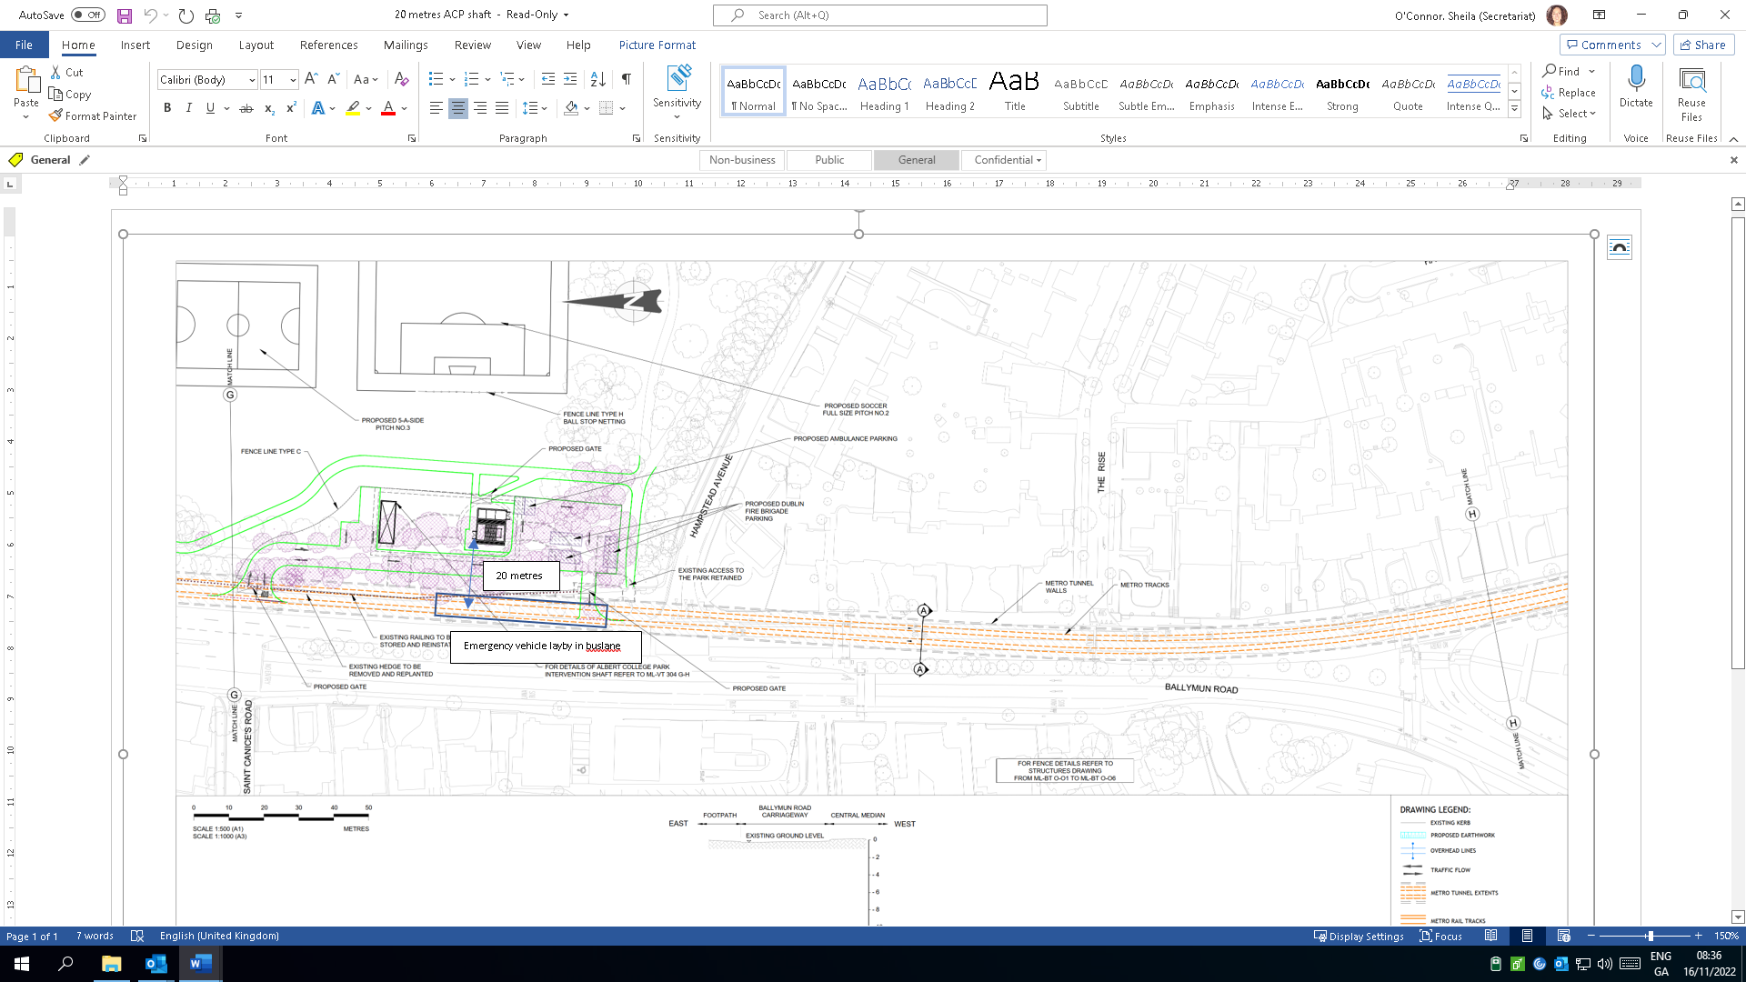

**Information Provided during Consultation**

GADRA continued to request information regarding the shaft during the consultation period on the PR March-May 2019 and, just two working days before the public consultation closed, during the final week of local and European elections, the NTA sent GADRA (and only GADRA) a hand drawn ‘map’ of the shaft, which showed an above ground structure. The NTA noted that the access area around the shaft was not shown on the map. Again, see below what was provided:

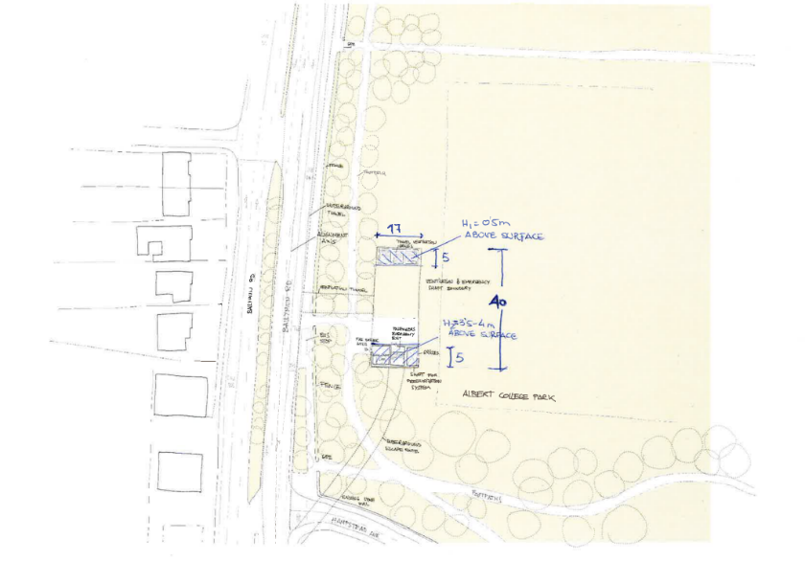

GADRA requested that further information be provided, and that the public consultation period be extended so that the shaft could be considered in the context of the PR. The NTA refused.

The decision to put an above ground shaft and emergency vehicle/ maintenance car park in a Dublin city park was taken without discussing the proposal with DCC (as confirmed to GADRA by the Head of Parks) or with the public.

The NTA /TII said that GADRA were the only ones looking for information in relation to the shaft- as GADRA had been through this process before on Metro North when the shaft was represented by a dot on maps until very late in the process and indeed it was only following the intervention of the late Tim Brick DCC that RPA produced drawings the shaft in that application process ( unfortunately this time DCC seem to be very giving with our public parks which they are charged with protecting for future generations). The general public are not meant to have to have a working knowledge of metros in order to be able to participate- the NTA TII were responsible to disseminate this information to all during the consultation phase. Indeed, the NTA TII refused information pertaining to the shaft design consultation under FOI only to have this decision overturned by Information Commissioner on appeal – this should never be required in a public consultation and again we ask that this position and size of this shaft is not agreed by ABP until proper alternative to its position and size has been undertaken. While it is not our intention to delay this project the NTA TII have had plenty of opportunity to address this issue in advance of RO Application

On February 12th, 2020, the NTA commenced in our view an inadequate form of consultation in relation to this Intervention Shaft. GADRA had been seeking a consultation, but consultation also in relation to positioning of the shaft in the park. However, the consultation that issued was on two issues only - Aesthetics and Construction Methodology. It is disingenuous for NTA to state in Section 8.6.5 Table 8.4 that people only commented on landscape and aesthetic when the TII gave residents a template only asking these questions!! While there is mention that the only other alternative is to put shaft with homes south of the proposed site, the NTA do not consider the proposal of a station at this site. The result of this consultation was refused on FOI only to be overturned on appeal to Information Commissioner. See questionnaire below

A station would fulfil all the safety criteria of the shaft, would meet the zoning requirements, and would benefit the local area. GADRA would like to draw the inspector’s attention to the lack of future planning at this shaft site within the DCC area (Section 4.6.3.11) unlike Fingal area DCC area is not taking the large land bank to the east and south of this shaft site and making this shaft a station for future use – it could act in the manner of Dardistown to remain inactive until these sites are developed. Overall GADRA feel that the NTA decision to hold this faux ‘consultation’ and limit the scope to the two issues of appearance and construction methodology, rather than on the substantive issue of location in a park, does not address the fundamental gaps in the consultation on this to date. This was not adequate as a consultation process. The public were not given any alternatives. The public are being asked to comment on a decision the NTA have made without any previous consultation - this is, in our opinion, a meaningless process. All the alternatives to this shaft were not assessed as part of this consultation. Finally, we note that the response leaflet as supplied to homes by NTA contained a response sheet that required no name or address and had no identifying number in spite of the Privacy Policy being reproduced on the reverse of it - we suggest that this brings into question the validity of submissions made in this way.

In particular, GADRA highlight the following issues with the report produced in relation to Albert College Shaft 2019 Report in particular noting the seriousness of points 1 and 2:

1. GADRA believe that the fact that Jacobs/ DOM did not include the option of a station at this site in the EIAR is a fundamental flaw with this assessment. Jacobs did not include any reason why a station was not considered.
2. Although the public were being asked in the restricted “consultation” on the shaft about the Environmental impacts of the construction stage, the actual Environmental Impact Assessment Report (EIAR)does not address this - again a fundamental flaw and a major issue with the current process. The report on the Shaft produced by TII states

* “*The location assessment gave consideration to a number of factors including environmental impact, constructability,”*
* *“The Environmental Impact Assessment Report (EIAR) to be produced a later stage of project development will identify all environmental constraints and impacts arising from both the construction phase and the operational phase of the project. To minimise potential environmental impacts, mitigation measures will be prescribed in the EIAR. The EIAR document will also specify the residual impacts that might remain following the implementation of the proposed mitigation measures. “*

1. In the introduction section, the report states that this preliminary design was developed from feedback provided during the public consultation process. GADRA find it difficult to believe that any member of the public gave feedback requesting a large works depot to be put into the park for the period of construction, in addition to agreeing to the final arrangement of the shaft and maintenance/emergency car park. We note and support the Hampstead Avenue residents’ submissions in this regard.
2. We note that it was confirmed to GADRA in May 2019 that we were the only group looking for information pertaining to the shaft, so do not believe the details regarding the shaft was widely circulated or communicated. It is GADRA’s opinion that no one else knew to be looking for this as they had no prior Knowledge of Metros
3. GADRA also note that local public representatives do not support the proposal to put a shaft into a public park preferring the option of a station instead.
4. See the email trail noting that NTA are confirming that details on the Shaft is not available during the consultation period

Email 1:

**From**: "Hugh Creegan" <[Hugh.Creegan@nationaltransport.ie](mailto:Hugh.Creegan@nationaltransport.ie)>  
**Sent**: Sunday, May 19, 2019 3:49 PM  
**To**: "[info@gadra.ie](mailto:info@gadra.ie)" <[info@gadra.ie](mailto:info@gadra.ie)>  
**Cc**: "Aidan Foley ([Aidan.Foley@tii.ie](mailto:Aidan.Foley@tii.ie))" <[Aidan.Foley@tii.ie](mailto:Aidan.Foley@tii.ie)>  
**Subject**: RE: Ventiation Shaft information released 2 days before end of consultation

Dear Mr. Webb,

I refer to your email of 18th May in relation to MetroLink, the period for submissions under the current consultation process and the proposed intervention shaft in Albert College Park.

At this stage of the project, TII/NTA are consulting on the “Preferred Route” for the project, which is an early stage of the planning and design process.  Not all of the details of the project are developed at this stage and final designs for the Intervention Shaft in Albert College Park are not yet available.

As notified previously, it is not intended to extend the MetroLink public consultation period.   You will, of course, be able to continue to engage with TII in relation to the development of the project, including in relation to this proposed Intervention Shaft at Albert College Park.

Finally, I note your allegations of breaches of the Irish Constitution and of the Aarhus Convention.  These allegations are simply incorrect.

Regards,

Hugh Creegan,

National Transport Authority.

Email 2:

**From:** Griffith Avenue & District Residents Association [<mailto:info@gadra.ie>]  
**Sent:** 18 May 2019 10:14  
**To:** Hugh Creegan; Foley Aidan  
**Cc:** [paschal.donohoe@oireachtas.ie](mailto:paschal.donohoe@oireachtas.ie); [marylou.mcdonald@oireachtas.ie](mailto:marylou.mcdonald@oireachtas.ie); Maureen O'Sullivan  
**Subject:** Ventilation Shaft information released 2 days before end of consultation  
**Importance:** High

Dear Hugh

We note your continued refusal of our reasonable request to extend the consultation period on Metrolink. We are very surprised at this given that, to date, there has been no consultation on the intervention shaft in Albert College Park. We made this point in our submission which we submitted this week in which we stated our objection to the Intervention shaft based on zero information concerning same.

Yesterday afternoon we received the email below with attached 'drawing'. To disseminate vital information just two working days from a closing date on the preferred option is totally unacceptable and according to our advice is a clear and serious breach of your obligations under the Aarhus Convention to consult.

The drawing and lack of detail is further evidence of a total disregard for consulting with residents in this area. We are now requesting that the extension to the closing date for submissions be a period of 6 weeks, which we are believe residents are entitled to, in relation to this new information. This intervention shaft is one of the few structures that will have a permanent footprint above ground and yet TII/NTA decided that it did not warrant consultation which is further evidence of the arbitrary nature of the NTA's dealings with different areas of citizens and appears to us to be unconstitutional.

As you know we represent an area with a high elderly residency who in many cases are not computer literate so for us to disseminate this information involves a printed newsletter. We are requesting that the TII hold an open day to explain and consult on the shaft design and land take (including that for emergency vehicle parking) to residents. Failure to hold a full six-week consultation on the design of this shaft will according to our advice no doubt be subject of a complaint and could form part of any appeal to ABP.

GADRA are supporting the call by the Ballymun Road Resident association and Albert College Residents to move the Collins Ave Station to NW corner of the park to protect their senior citizen complex and to avoid the need for a shaft and should result in a decreased cost of the project.

Kind regards

John Webb

Chairperson

GADRA

 Email 3:

**From**: "Angley Suzanne" <[Suzanne.Angley@tii.ie](mailto:Suzanne.Angley@tii.ie)>  
**Sent**: Friday, May 17, 2019 2:49 PM  
**To**: "[info@gadra.ie](mailto:info@gadra.ie)" <[info@gadra.ie](mailto:info@gadra.ie)>  
**Cc**: "Metrolink Information" <[info@metrolink.ie](mailto:info@metrolink.ie)>  
**Subject**: Albert College park

Dear Ruth,

Please see below from Jacobs Engineering. We asked them to put this together for you following on from your queries on the ventilation shaft at Albert College Park.

Also I would like to thank you for your submission which we received this morning.

*From Jacobs:*

Please see attached a sketch of current thinking for this shaft, but please note that design is currently in progress so locations may change slightly. Emergency service/maintenance access from Ballymun Road is not currently shown.

The emergency access and ventilation shaft is required at this location due to the tunnel distance between Collins Avenue station and Griffith Park station exceeding the maximum distance for emergency access and tunnel ventilation requirements. This shaft will thus provide both an access point for emergency services in the event of an incident in the tunnel between Collins Avenue and Griffith Park and will provide an emergency escape route for passengers if required. The shaft will include ventilation equipment to ensure tunnel ventilation and smoke control can be managed safely in the event of a fire.

The underground element of the shaft is envisaged at around 17m by 40m. However, the visible surface elements following construction will comprise:

* Ventilation grilles of an area 5m by 17m and set about 0.5m above ground level
* A building of similar area at the opposite end of the shaft but around 3.5-4.0m in height to incorporate the lift shaft building; stairs exit and pressurization shaft with associated side-facing grilles set at 3.5m above ground level.
* The area in between the surface grilles and the buildings would be accessible at ground level.

The architectural finishes for the buildings and raised grilles have not yet been determined and the extent of any screening will be undertaken during the environmental assessment of the works in this area. However, it is our intention to ensure that the structure will be as visually unobtrusive as possible.

Kind Regards

Suzanne Angley

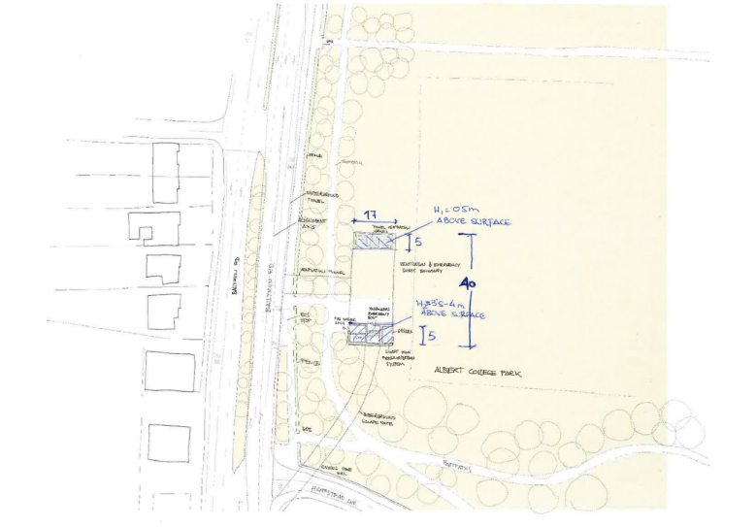

1. GADRA note that Section 4.1 Table 1 of the Shaft report indicates that the distance from Glasnevin Station to Mater Station is 683m. This shows that a station in Albert College Park would not result in a distance between consecutive stations that is out of line with the distance between other stations on the Preferred Route.
2. GADRA note that in Section 4.3 of the report on the shaft the NTA appeared to have considered putting this shaft into the residential area along the Ballymun Road and The Rise. Given that the need for this shaft was driven by a decision to save a GAA pitch from an underground station, we are shocked that putting the Shaft into a residential area was considered

*“For the tunnel intervention shaft to be no more than 1000m from either Collins Avenue or Griffith Park Stations, it must be situated either immediately north of Hampstead Avenue in the south-west corner of Albert College Park; or within the residential area immediately south of Hampstead Avenue*;”

1. We also note and object to the permanent loss of park lands and we object to any access from Hampstead Avenue as detailed:

*“Provision for vehicular access to maintain, service and, if necessary, replace tunnel ventilation and emergency access equipment has been incorporated into the design. The main point of access will be from the Ballymun Road with a secondary access provide from Hampstead Avenue. A large area for parking of emergency vehicles and routine maintenance vehicles has been provided to the southern end of the site. The tunnel ventilation shaft and associated parking and structures will be contained within a secure fenced area.”*

We also note that the DFB have not had any input into the design of this shaft having only been consulted recently and the DFB have confirmed that they are just looking for best international standards which means a hard standing area for two fire engines be available for emergency vehicles within 20 meters of the shaft- the layby on the Ballymun road satisfies this criteria negating the need for an area of the park to be incorporated into this shaft design thus reducing the permanent land take from the park.

1. GADRA note with concern that the construction methodology of drilling and blasting appears to be the intended method by which this shaft will be constructed (Section 5 of shaft report) with a proposed depth of 30m, which we believe to be the deepest point along the Metro route. We note that homes are situated less than 20 meters from this blast site. We cannot see that the NTA have considered as part of this report the human health issue as part of an EIA and note our opposition to the plan. We are asking that VBM is used in the formation of this shaft
2. NTA/TII have omitted baseline sound monitoring from this location, and this also must be addressed prior to RO
3. The report does not contain the impacts on this structure as part of the build

*“The proposed intervention shaft at Albert College Park differs because it involves construction of an underground plant and fan room. This room has design dimensions of approximately 43m x 20m x 10m deep and it will be located above the shaft as shown in section 5 of shaft report”*

1. GADRA note that the report states that shaft is a significant construction - so we ask again why this significant construction was excluded from consultation on the Preferred Route and was omitted from the EIAR- this needs to be addressed prior to granting RO. Remembering that GADRA specifically requested that the consultation at the Preferred Route stage be extended by 6 weeks for this structure to be considered. Furthermore, it is our position that the decision to omit this structure from that Preferred Route consultation means that reopening consultation must be considered.
2. GADRA totally object to the plans for a temporary construction compound (see Section 5.1 of shaft report below) and we object to the loss of the park for the duration of 3 years – noting that this does not include the length of time required for the park to recover and be available for public use. In contrast to the shaft report the EIAR says the construction will take 5 years.

*“A temporary construction compound will be required for the construction of the shaft, the passages connecting the shaft to the main tunnel, and the associated mechanical and electrical work. The extent of the proposed compound is shown in Figure 13. The compound layout includes suitable areas for the access road off the Ballymun Road, offices and parking, construction material storage, workshops and excavated material storage. The temporary area required for the compound during construction period is greater than the area which will be ultimately required for the completed tunnel intervention shaft.*

*It is estimated that the overall construction period for the tunnel intervention shaft will be approximately 3 years.”*

1. GADRA note the report does not contain any assessment of the short medium- and long-term effect of the proposal. As previously stated, a major flaw.
2. On review of Section 6.1of shaft report there is no assessment of the impacts on the residents living less than 20 meters from this site - although the report does make reference to the impact on the playing pitch.
3. GADRA request that a precast roof be used during the construction of the shaft to mitigate impact on residents
4. GADRA request that this site is a dark quiet site at night with no works taking place on it given that this site is adjacent to the main tunnels and its proximity to home and the flora and fauna of the park.

Of note the NTA/TII refused to release the submissions made during this mini consultation to us under FOI, and we had to complain to the Information Commissioner who upheld our complaint requiring that they were finally released to us.

So, in summary in relation to consultation on the shaft, we feel that the NTA did not put the shaft into the consultation on the PR. They have omitted it from maps - even the maps included in this EIAR does not include the shaft on the maps section. This means that residents have not been afforded the same rights to participate as all other residents throughout the city - producing a hand drawn sketch 2 working days before end of consultation and providing this only to us, stating that no one else was looking for it, is not appropriate. No one else knew to look for it because NTA TII had not mentioned it in their documentation. In addition, no one knew it was above ground structure – GADRA knew because we had been through Metro North, but it is neither reasonable nor supported by law that residents are obliged to have a previous working knowledge of metro construction in order to participate in consultation processes.

The NTA did not and have shown no evidence or looking at alternative either the changing of shaft to station – moving the Collins Avenue Station to NW corner of Albert College Park and moving the shaft to car park to Ballymun Library (noting that zoning supports this). We are asking the Inspector to look for alternatives to this shaft and to request full consultation on the alternatives before granting the Railway Order. We fully support the ACRA proposal to move the Collins Avenue Station to Northwest corner of Albert College Park, thus negating the need for a shaft in the park - especially given that there is no precedence for a shaft in a park.

The Shaft has not been included in the EIAR in many of the chapters, even though it is a large deep construction. In Chapter 4 Section 4.6.3.4 there is no mention of the shaft at all, no mention of its proximity to Cuilin House, or 114 Ballymun Road, which is a protected structure. Section 4.17.5 refers to the ACP Intervention Shaft as a rectangular box *–*

*The upper level has been designed as a concrete box with maximum dimensions of 39.7m long and 15m wide. The lower level, with an internal diameter of 19m, provides enough space for stairs to evacuate the passengers during an emergency and a lift to provide access for the fire service and the evacuation of injured people. A small building will sit over the stairs. At the bottom, the shaft connects with the railway tunnel via separate gallery/mined tunnel connections for passenger egress, emergency service access and for tunnel ventilation. All the walls connecting the main tunnel with the galleries will be made of reinforced concrete providing a two-hour fire rating. Fire doors, also with two-hour fire rating, will be provided in the dividing wall between the main tunnel and the access gallery to ensure the complete fire compartmentation between the galleries and the tunnel. A maintenance access road from the R108 Ballymun Road and associated hardstanding area are provided at the intervention shaft in Albert College Park.*

For this to have been omitted from consultation is not acceptable.

There is no attempt to blend this structure into its surrounding areas as there has been with other stations where, like for example with Section 4.17.4.2 where there was consideration of the relationship between School and Station in relation to design principles and in Section 4.17.6.2 Griffith Park Station the incorporation of a green wall into the design. Yet the proximity to Cuilin House and 114 Ballymun Road, and its situation in a park, have not influenced the design at all – they are giving residents, and we quote ‘a concrete box’. The complete lack of consideration and ambition in the design of this shaft structure is obvious and we are requesting that the Inspector make it a condition of Railway Order that this shaft is designed in keeping with the historical structures around it. They need to look at many examples from UK. It is almost like the design of this shaft was not considered other than as an afterthought.

We object to the additional emergency exit on to Hampstead Avenue, which was objected to by residents as soon as NTA decided to inform them of the shaft’s existence. Again the required second exit can be accommodated on the Ballymun Road.

**Construction**

In relation to hours of work, given the proximity of the Shaft to homes - less than 15 meter to boundary (Section 5.2.4.2) - we are objecting to additional hours of work. Given that the shaft is adjacent to the tunnel and will not directly impact time frames for the main tunnels and project, we are requesting daytime standard working and delivery times (table 5.3) only. Unlike the stations which are integral to the project time frame, the shaft is a standalone structure and residents are prepared to have the construction continue for longer, if it occurs only during standard hours. GADRA are requesting that the inspector attach a condition in relation to the SCL tunnel and main tunnel that it occurs during standard hours only, thus limiting the need for 24-hour site lighting for pumps to the SCL compound (Section 13.5.2.1). We are asking that inspector makes this site a quiet dark site at night. There was no night-time works on shafts in the building of the Milan metro and no need for it here. It was confirmed by experts that this SCL can be completed by day works only.

The ground water level at this shaft site is high and much grouting works will be required , and we note that the 23meters emergency evacuation tunnels connecting the main tunnel from the shaft will also be below the water table, which makes the excavation of these tunnels difficult as they not be formed by TBM which has a sealing system. We again ask ABP to make sure that NTA TII have fully satisfied ABP as to the positioning of this site, which is one of the deepest along the route yet has high water table. Indeed, the hydrology to the north of this site is deemed better and the site at the NW corner was already approved in MetroNorth as being suitable for a station.

We note that no base line noise monitoring was carried out at this site in the EIAR (Section 13.29), and we are requesting that the inspector requests this prior to the granting the RO. However, we know from Metro North that the base line at Elmhurst NH was at a level that was as quiet as the countryside, at below 35DCB. NTA propose to use this Shaft as a SCL Compound (Section 13.5.2.6.3) for 24/7 works, including concrete pump site loader, ventilation fans, site power and lighting, with additional support plant for SCL with planned concrete deliveries at night The expected noise at this site (table 13.60) weekday is 70DCB, which is significant. Even with mitigation, this reduces it by 24 decibels only, which is not adequate as at night-time it will be of the order of 55-60DCB. This does not include the added noise of cement deliveries, which NTA plan for at night. Given this location within 20 meters of homes and being adjacent to the tunnel, we are requesting that SCL occurs by day, or the compound is in the tunnel with deliveries via the tunnel.

We also request that NTA uses a Vertical Shaft Machine for the construction of this shaft which makes vertical holes. It’s a 15m machine, with a lot of high-level technology. With this machine, the spoil could be mixed with bentonite and be removed in pipes like slurry.

We would also object to plans to avoidable night-time works at both Collins Avenue Station and Griffith Park Station, specifically in the context of the proposal in Section 13.5.2.6.4 to night-time strip and clean via Griffith Park in the interests of time efficiency and ask that the Inspector add as a condition that strip and clear is carried out at a station that is situated away from residents. We note the EIAR give no traffic impact at the Griffith Park site for this strip and clean activity.

We also note that no sound monitoring is being carried out in the Walsh Road / Homefarm Road area during construction – and note that given the above ground topography, the noise generated currently at Na Fianna, Homefarm and Scoil Caitriona travels right up to Homefarm Road and, given the near silence at night within this area, these night-time works will impact on people in the larger area. We would request that the inspector request as a condition monitoring of construction noise at these locations and removes all but essential night-time works from Collins Avenue Station and Griffith Park Station as time efficiency is not an acceptable reason to justify the impact that will arise.

We note the planned construction of the shaft is to use secant Piling (section 5.5.2.1) rather than the D walls of most of the stations. While we believe this is a quieter construction in relation to Diaphragm wall, we have reservations in relation to waterproofing and watertightness and, given the hydrology/water table at the Shaft site, we have concerns. We are asking the Inspector to be satisfied that this is the correct method for this position

Regarding Section 5.5.11, we note that the shaft will require two 23m long connection tunnels from the shaft, connecting to the main tunnel (see the general arrangement of the shaft in Diagram 5.27). Both tunnels will be constructed using the Sprayed Concrete Lining technique (SCL), which consists of cycles of excavation followed by the application of shotcrete (sprayed concrete), rock bolts and steel girders. The final connections will then be made from the main running tunnel (See Diagram 5.28). As with the underground stations, drilling and blasting may be required for rock excavation during construction of the tunnels. Given that the process consists of cycles, we are asking that this is a day-time activity as a condition. It has been confirmed to GADRA by RINA that SCL can take place by day only on this site and that like Milan no night-time works on this site are necessary.

We ask why the ACP shaft has a Main Construction Compound (Section 5.10) and we query the size of the compound Table 5.6, which is similar to the Station compounds.

We also have safety concerns (Section 5.10.4) that the planned construction route for traffic leaving the site is a U turn on the Ballymun Road, given its proximity to a primary school

Section 5.10.5 refers to an additional site being required as a lorry holding area to control the flow of HGVs into the site. This site has not been identified and we are asking the Inspector to set as a condition that the residential street of Homefarm/ Walsh/ Island Roads are not used for this activity, and that waiting trucks are required to turn off engines to ensure they do not continue to cause emissions while idling.

We know that the schools within the area have requested separate protected entrances to their schools throughout construction Section 9.4.5 Table 9.5 and we support this call. However, we cannot see how this can be achieved safely from Mobhi Road and, given that Vol 3 section 9.6.1.2.4 Table 9.64 shows the loss of south bound bus lane cycle lane and footpath on eastern side, with complete loss of all segregated cycle ways. We are asking that NTA in association with DCC and local stakeholders divert school pedestrians and cycling away from Mobhi Road and allow access to Scoil Mobhi, Scoil Aine, Scoil Caitriona, the Naonri and Na Fianna via Walsh Road and Griffith Park, with a designated cycle way through the park running North South and East West to prevent potential accidents with walkers. This would allow access to the schools from the rear of campus throughout construction. Walsh Road has been designated as part of the Greater Dublin City Cycle Network and has already been closed off to through traffic so, with minimal disruption, a cycle track could be put in, allowing very young children to cycle safely to school. Walking trains could be set up to walk groups of children safely through the park into the education hub, without the stress of the congestion, dust and noise of the construction site that will be Mobhi Road.

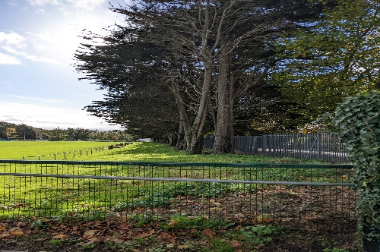

***Na Fianna Trees***

Although we have fully read the Metrolink EIAR and Ballymun CBC EIAR, we cannot understand if it is intended that both projects would occur at the same time. We suggest that it would be foolish to proceed with the CBC construction only, to then close it off again to rip it up for Metrolink, and we are appealing to the Inspector to delay the felling of trees within the Na Fianna fence (section 17.3.4.1.2) until after the construction of the station box, to prevent the loss of the carbon sink that these tall mature provide. The trees will also help in sound mitigation, will be dust limiting and will help offset CO2 emissions, so we are asking that this tree felling is delayed.

We do ask though that (Section 10.3.5.1.2) Schools are not rated higher than residences who may have people present in the 24 hours a day with many people still working from home, and we would not support a decision for night-time works at this site justified on the basis of facilitating the schools, which could be temporarily relocated.

We would like it noted that we have concerns in relation to Aspergillus and Immunocompromised residents (10.3.6.6.1) and would like this monitored closely, given that the current Pandemic has left increasing numbers of people with compromised immune systems in many cases unbeknown to themselves.

**Proximity of the Griffith Park station to the highly sensitive Tolka river**

As indicated earlier, we cannot see in the EIAR evidence in relation to the decision to move the Na Fianna Station to Homefarm Football Club (HFC). We note that the EIAR states that the Hydrology is not as favourable at the new Homefarm site, and it is a more sensitive site from a heritage point of view (7.7.10.8). Indeed, it seems to imply that the station position on the Emerging Preferred Route ( EPR) was preferrable to that on the Preferred Route (PR). Given the extremely close proximity of the Griffith Park Station to the River Tolka, 25 meters away, in an area that has previously flooded (section 18.4.3.4.2), we can see no technical reason for the move of station in the EIAR. It does imply in the EIAR that the reason for the move is that the impacts of the station at Na Fianna would be bigger on the Club than a station on Homefarm pitches would have on the Homefarm Club (section 7.7.2.1). We are asking ABP to be fully satisfied that this station is in the right position from a technical point of view, in the context of the risk of flooding and the potential for significant impact should a flooding event occur.

We note the impact that this move of station is to bring the tunnels under more homes, especially in the prospect ACA area who need to be afforded extra protections given the nature of their shallow foundations and age of their homes.

We also note the very large plaza in front of the Griffith Park station, right to the river’s edge. Given that the Valley of the river Tolka is a conservation area, although non statutory, area (27.4.2.18), we would request that the plaza is made smaller, and we would be fearful of anti-social activities at this site. Indeed, we can see no evidence as to why the stations have such large concrete plazas throughout this project and feel all should be reduced in size. It appears designers saw space and decided to use it, rather than trying to limit the above ground impacts throughout – we again mention the car park /Maintenance area put into Albert College Park for the shaft even though the hard shoulder on Ballymun road is within 20 meters of entrance and satisfies best international standards.

**Other Considerations**

We note the planned establishment of a project construction traffic Forum with representatives from key stakeholder groups, including residents. This forum must be set up with clear terms of reference with binding authority (refer Section 9.7.1,2)- we would again feel that the role of the Independent Experts needs to be included here.

We find it unacceptable that the contractor will be responsible for informing stakeholders of works – Section 11.6.1.2. This responsibility remains with the NTA, and residents should not have to deal with multiple contractors. In addition, we are unsure of how the CRO will work which was not clear in the EIAR.

We are asking that the Inspector makes it a condition of the Railway Order that Independent Expert advice continues to be available to the residents during enabling works and constructions, so real time independent expert advice is available to residents for the area that are living in. This is especially relevant to real time air/noise/vibration/dust monitoring. We do not feel that the NTA/TII should be in charge of this aspect of the project, but that it should be managed by the Department of Public Expenditure or Transport.

The EIAR refers to construction workers using sustainable transport to work (9.7.1.1) - we also feel that surrounding roads may need pay and display or resident only parking- indeed Hampstead residents have already documented issues with parking for agents of the NTA in their submission.

We would ask where these workers will live, if, as expected, many workers from abroad will be required for the Metro. We also ask as to where all these workers will be sourced, as it is likely that there will be a shortage of qualified workers available.

We note the request in relation to limits of deviation (Chapter 6 pg. 17) where there is a request for 15 meters laterally with station boxes, which we feel is too great and much larger than was requested or granted in MetroNorth. We cannot see a justification within the EIAR for this proposal and ask that Inspector set tight levels of deviation. We also request that the zone of influence moves accordingly. We are requesting a Construction limit of deviation of one meter sideways and vertically as any greater than this will impact on settlement calculations. We know that tunnelling is a dynamic process and again highlight the need for Independent Experts throughout construction.

EIAR Chapter 9 omits the shaft from its scope assessment of road transport and impacts on pedestrian and cyclists.

We support the submissions of ACRA and Ballymun road Residents Association, Hampstead Residents, Prospect ACA and Charlemont residents.

We have major concerns in relation to the plans for Glasnevin station - this is going to be a huge site joining two existing railway lines and building the MetroLink and a large above ground station building. This building is not in keeping with the area in either style or size and this needs to be addressed before the granting of the RO. We feel this is an extremely ambitious plan involving many different organisations and construction teams, and the overall ownership of this needs to be clarified – it was not made clear in the EIAR. The construction methodology for this massive area needs to coordinated and managed by one entity, and we would ask that the role of the Independent Experts is expanded here so that they have full oversight of not just the Metrolink build, but also the Rail realignment and the marrying of the projects – this is of utmost importance so issues emerging cannot be blamed from one to the other (already we have TII telling us that an issue is NTA, and NTA telling us an issue is TII and Minister telling us that all issues have nothing to do with him). We would also ask for an extended role for Independent Expert in the Charlemont area where the 1Km extension to Charlemont is to facilitate the Luas extension – this also needs to be monitored as the two different transport teams will again need oversight.

In relation the Prospect ACA these Victorian homes are on very shallow foundations, and we feel this area need extra attention, which is not apparent in the EIAR. In addition, the Zone of Influence needs to be extended to a wider area and to include all homes in a terrace. Also, we request that this extended zone be further extended in level of deviation increases.

GADRA fully supports the call by associations for Community Fund and Residential Monitoring Group

We have major concerns that the canal will be drained for such a long period and fear that it will not recover for years, if at all. This, combined with the potential impact on the Tolka river by Griffith Park Station, needs to be looked at further prior to granting the order.

We further note that no night-time above groundwork occurred on station boxes or shafts in the building of the Milan metro and we are requesting this for all the stations and shafts. We also are requesting that the mainline rail realignments also occur by day only given their proximity to homes at the Glasnevin station.

**In Conclusion**

* GADRA do not feel the EIAR is complete in relation to the decision to change from Twin to Single Bore – we do not see clear reason for this massive change. We would like to highlight that the moving of TBM launch site and Griffith Park station do not necessitate a change from Twin to Single bore - the change is a decision that NTA made separately but have not given evidence as to why this decision has been made in the EIAR.
* The Fire/emergency safety issues associated with a single bore tunnel have not been addressed in the EIAR. DFB have confirmed that they have had no input into the design of the project or the shaft – this has been confirmed to RINA and GADRA by the TII. It is only at the very late stage of this project (just a couple of months before RO application) that Atkins were brought on as consultants in this area, and therefore rather than designing safety into the project at the design stage, it is being addressed retrospectively on an already designed project. The Atkins report is not part of the EIAR.
* The increase in settlement from a single bore rather than twin bore has not been addressed in the EIAR and we would be requesting an appropriate increase in ZoI in relation to settlement and all monitoring and mitigants to be employed.
* We have concerns in relation to the change of the Griffith Park Station position. Given its proximity to the high value Tolka river, the poorer hydrology at the new site, and the settlement issues being more significant for the Prospect ACA as the Victorian housing has shallower foundations. We do not feel that the EIAR has shown evidence supporting this move in the station position, nor has it fully addressed the increased mitigations required following this change.
* We have throughout objected to the use of a public park zoned Z9 to house an Intervention Shaft and parking area and asked for this to be either changed to a station or the position of Collins Avenue Station be moved to avoid the need for this shaft in its current position. We will never have an increase in parkland within this area, so to give away a park that has been protected for hundreds of years when there are realistic viable alternatives is not good practice. RINA have confirmed that it is not common to put a shaft into a park and have not been able to give us an example of a shaft in a park on another metro as they are usually placed beside buildings. The EIAR does not show any evidence the TII /NTA seriously looked at any alternatives to this current option – it looks like they were reacting to the unexpected request to move the station from Na Fianna site. The EIAR is lacking in all aspects and all chapters in relation to the Shaft - scoped out of noise vibration traffic air quality – it looks like these baseline monitoring had been completed prior to the TII decision to put the shaft in ACP and baseline monitoring was omitted from the site. It would be remiss to proceed until all the baseline monitoring has been completed in relation Hampstead homes.
* We do not believe that Albert College Park with the current Z9 zoning supports the shaft location, which is adjacent to the tunnel and not integral to the tunnel and cannot in itself be considered green transport.
* The Z9 zoning does not in any way support a car park or maintenance depot in the publicly owned park. Any requirement for a hard standing area is satisfied by the existing hard shoulder on the Ballymun Road, which is within 20 meters of the shaft entrance and therefore the proposed hard standing area should not be approved in its current position
* GADRA are asking that the Collins Avenue Station is moved into the park, negating the need for a shaft in the park- the decision to position this station at Our Lady of Victory Church is not supported in the EIAR. The drip feeding of information in relation to this site and decision-making process clearly indicates major issues in the decision making process.
* GADRA request that the school children in OLOV school are treated with the same respect and given the same consideration as the children one kilometre away on Mobhi Road. Just because OLOV were unable to mount a nationwide campaign with political support, they are being left in the position that was objected to and resulted in the movement of Griffith Park station.

In relation to the Shaft, GADRA are requesting:

* That ABP makes it a condition of RO that the shaft footprint is reduced, and parking for emergency vehicles is positioned outside of the park on Ballymun Road, which satisfies requirements of a hard standing area within 20 meters of entrance to shaft
* The Shaft is daytime works only and it is a dark quiet site at night
* No strip and clean at night via Griffith Park station
* No night-time works above ground on station boxes
* No mainline rail realignments work at night unless absolutely necessary, and local residents to be relocated during this work
* Zone of influence to increase in areas where homes have shallow foundations and mitigants be employed
* Role of Independent Experts to be extended into phase two – enabling works and construction and to include oversight of multi-agency construction sites – Glasnevin and Charlemont.
* Ownership of project needs to be defined legally, with clear dispute mechanism
* Clearly defined actions should the project have a protracted term, stall or be stopped completely to reinstate areas to former conditions and make them safe during delays

**GADRA Nov 2022**